

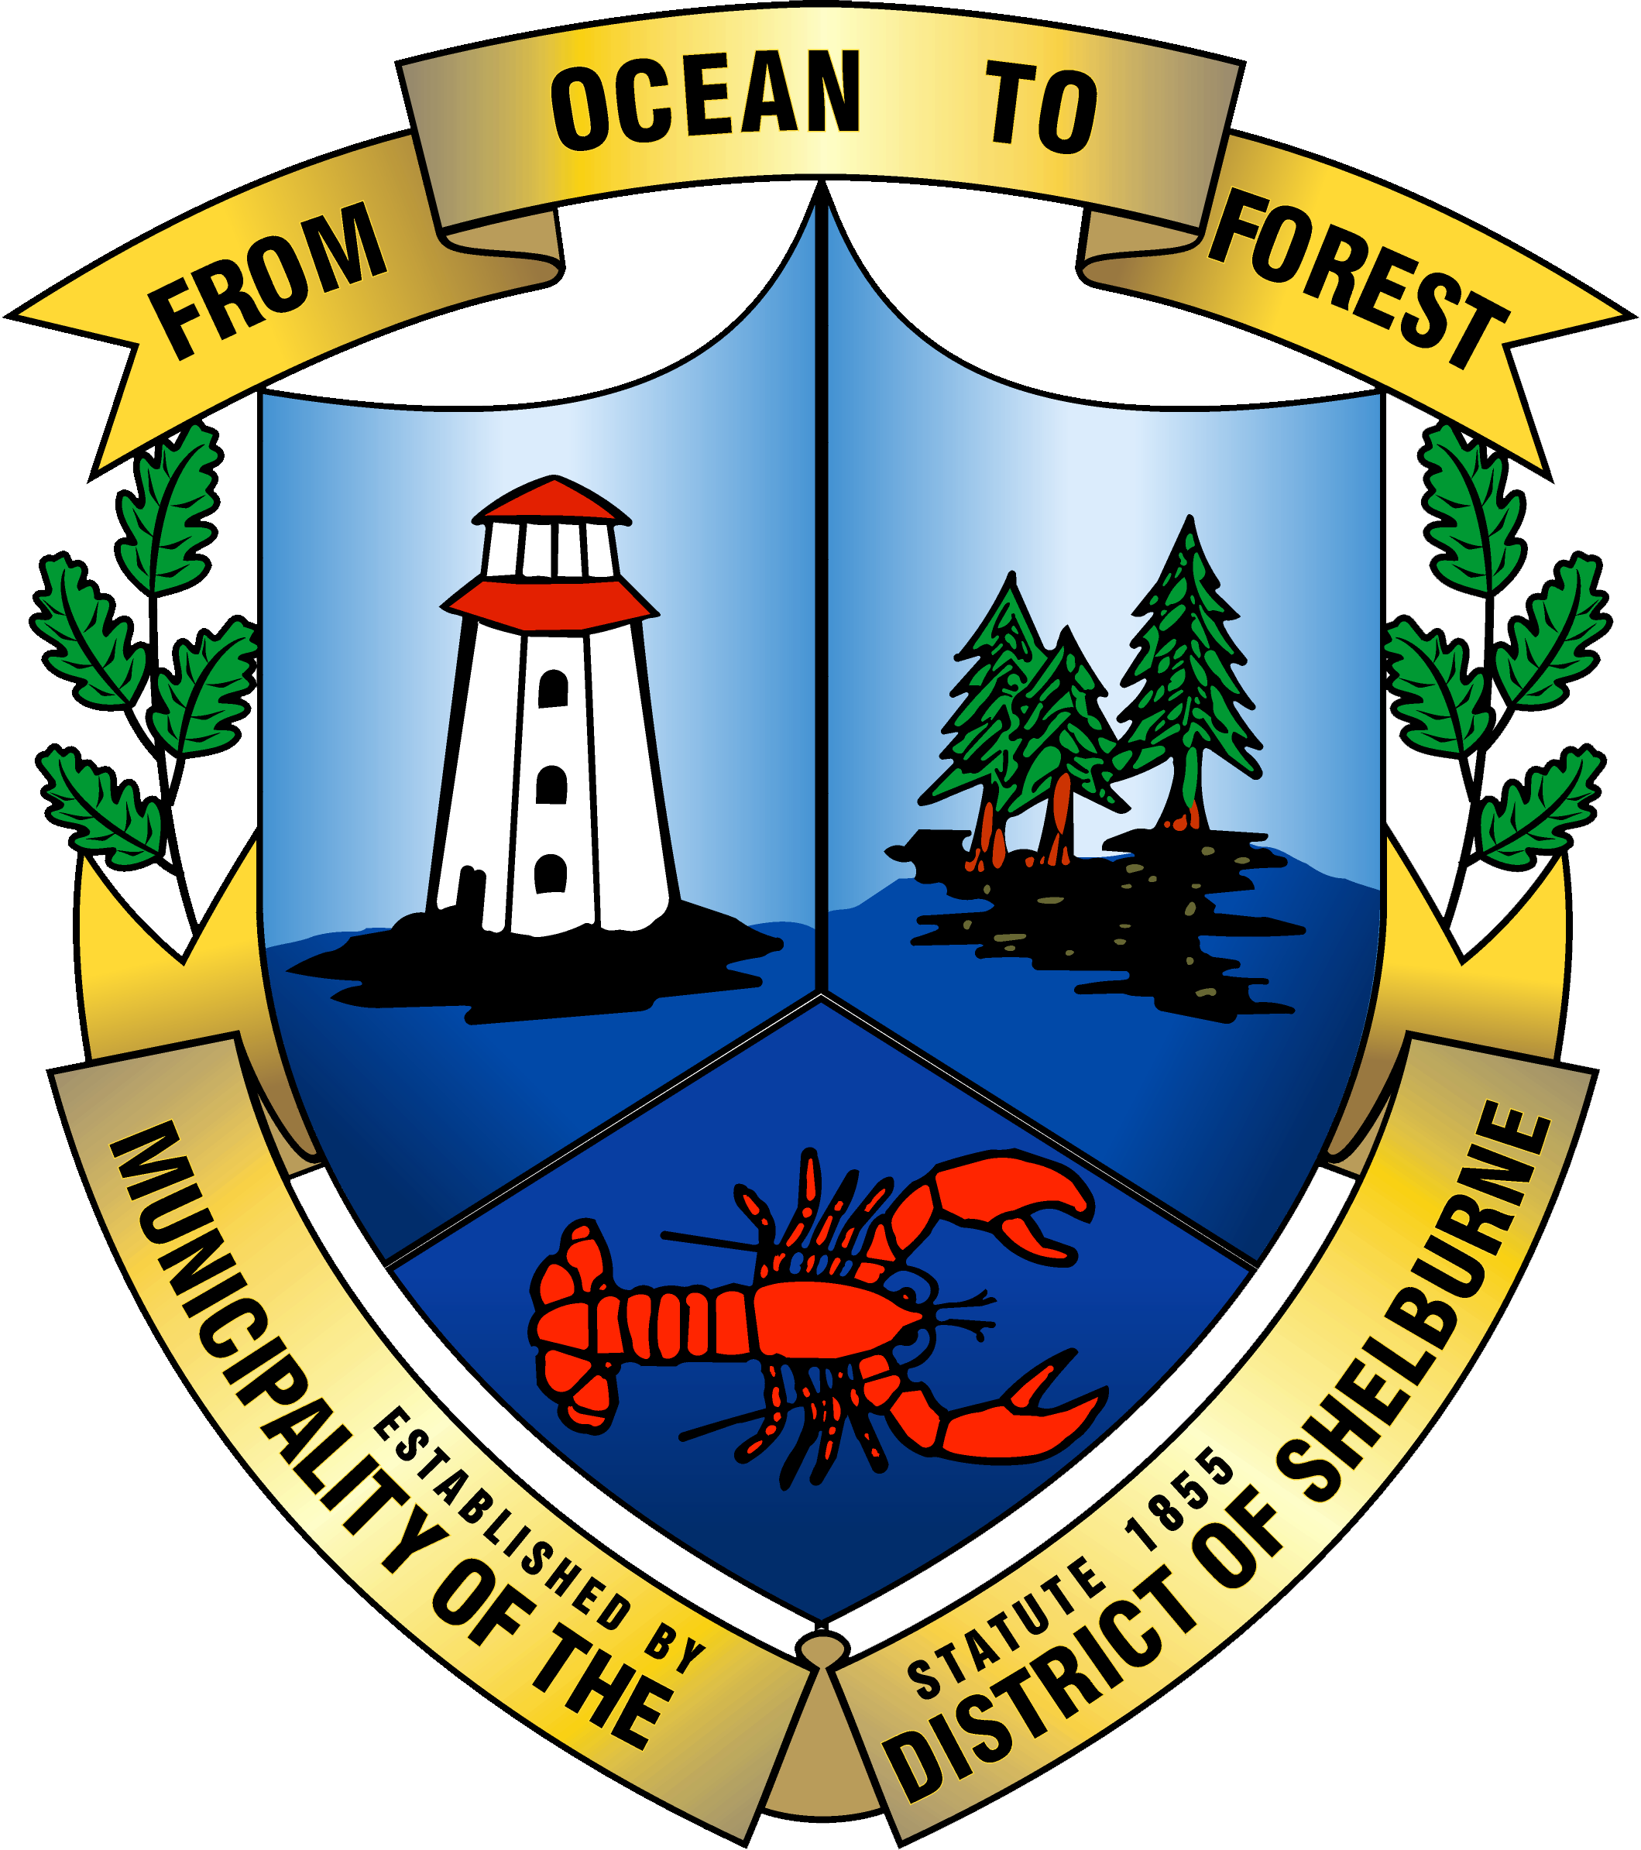

Eastern Shelburne County Accessibility Advisory Committee Meeting
July 21, 2021

Agenda

- Call to Order

- Agenda Approval

- Minutes of Last Meeting

- Business:
  - RFP Accessibility Plan Recommendation
  - Next Steps
  - Review Workplan
  - Check-in

- Other

- Next Meeting Agenda Items

- Next Meeting Date

- Adjournment

