

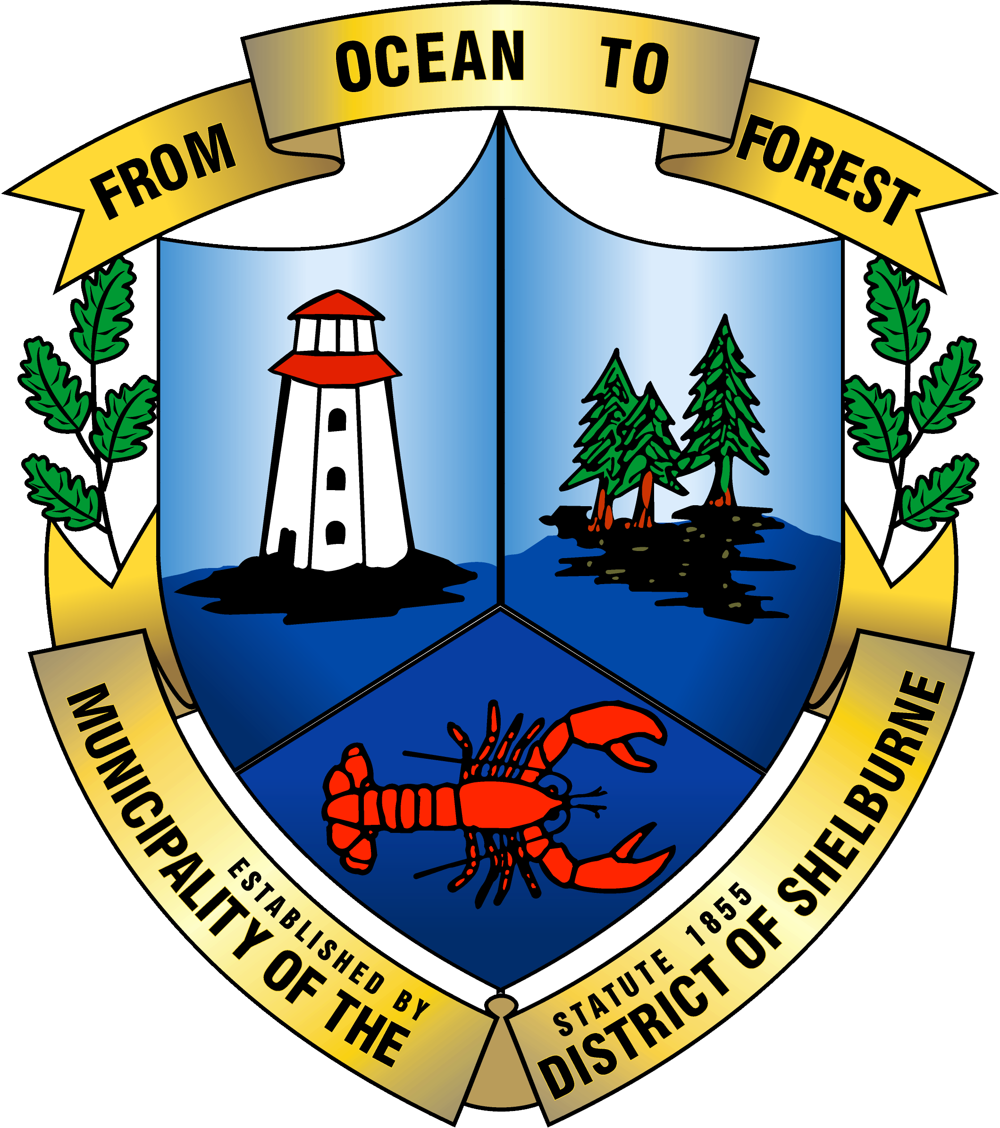

Eastern Shelburne County Accessibility Advisory Committee
Nomination Committee Meeting
June 16, 2021

Agenda

- Call to Order

- Agenda Approval

- Minutes of Last Meeting

- Business:
  - Review of RFP for Accessibility Plan
  - Funding to support cost of RFP
  - Learning opportunities for committee members

- Other

- Next Meeting Agenda Items

- Next Meeting Date

- Adjournment

